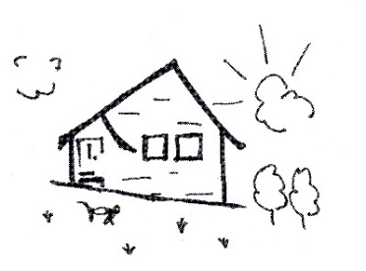
KNUTSFORD IYENGAR YOGA CENTRE
www.KnutsfordYoga.co.uk

RE-OPENING OF THE CENTRE - SAFETY ARRANGEMENTS
The safety of our students and teachers has always been our top priority, so we have taken steps to ensure that our classes will be as safe as possible for everyone.

- There will only be 10 students in each class - the hall floor is marked with tape so everybody will have their own space.

- Walkways have also been marked to allow you to move around the room without standing on another student`s space.

- There will be no physical adjustments by the teachers.

- Face masks will be optional for both students and teachers

- Students are asked to bring their own equipment – a mat, one belt, four foam pads and two blankets (or two large bath towels). We will use the chairs from the Centre as they can easily be disinfected between classes. We will minimize the use of props in the Foundation Classes but these students will still need one mat, one belt and either two blankets o two large bath towels.

- If you wish to buy equipment from the Centre please fill in an Equipment Order Form. This link can also be found on our website – www.KnutsfordYoga.co.uk

- There will be at least 45 minutes between classes to allow time for cleaning and disinfecting.

- Students are asked to come `ready` for class and to leave their belongings in their cars – depending upon weather!!

- Doors will be opened ten minutes before the start of the class.

- Students are asked to observe social distancing as they enter the building and to wait at the door if there is another student in the Entrance Hall.

- There will be a hand sanitizer on the wall in the Entrance Hall which students will be asked to use before entering the Hall.

- Sorry - no `cups of tea` after class as we will not be using the kitchen. Please bring any drinks that you might need.

For further information, please contact Margaret Carter
Tel No: 07807 348441 Email: KnutsfordYoga@aol.com

